Traditional and Improved Spate Irrigation Systems in eastern Ethiopia, the case of West Harerge, Mi’eso District

Document

By

Abebe Mengistu

June 2010
Haramaya University

HARAMAYA UNIVERSITY

SCHOOL OF GRADUATE STUDIES

Traditional and Improved Spate Irrigation Systems in eastern Ethiopia, the case of West Harerge, Mi’eso District

Abebe Mengistu

Faculty: Institute of Technology
Department: School of Natural Resource and
Environmental Engineering
Program: Irrigation Engineering
Advisor: Tena Alamirew (PhD)

February 2010

Haramaya University, Ethiopia

CONTENTS
1. INTRODUCTION 1
2. LITERATURE REVIEW 4
2.1. Irrigation 4
2.2. Spate Irrigation 5
2.3. Agronomic Aspect of Spate Irrigation Areas 7
2.4. Sedimentation 8
2.5. Water Rights and Water Distribution Rules 8
2.6. Field Water Distribution Strategies 9
2.7. Topography 9
3. MATERIAL AND METHODS 11
3.1. Area Description 11
3.2. Methodology 13
4. RESULT AND DISCUSSION 14
4.1. Bililo Modernised Spate Irrigation 14
4.2. Waltane Traditional Spate Irrigation Scheme 20
4.3. Hargeti Modernised Spate Irrigation 27
5. SUMMARY 32
6. LOGISTICS 34
5.1. Budget Break down 34
6.2. Budget summary 34
7. REFERENCES 35
8. APPENDIXES 37
8.1. Hargeti galleries 38
8.2. Bililo galleries 41
8.3. Waltane galleries 45

1. INTRODUCTION

In Ethiopia agriculture is the backbone of the country’s economy, with the majority of the population engaged in this sector. The dependency of most of the farmers on rain fed agriculture has made the country’s agricultural economy extremely exposed to the effects of weather and climate. A failure of rains and the occurrence of drought or consecutive dry spells during the growing season lead to crop failure, which in turn leads to food shortage.

According to World Bank report (2006) Ethiopia’s growth will be undermined until it attains water security, and it will require very large investment to achieve a nationwide minimum platform of water infrastructure and management capacity. Unmitigated hydrological variability increases poverty rates by about 25 percent and costs the Ethiopian economy about 40 percent of its growth potential, leaving growth rates hostage to hydrology. Managing this variability will be a prerequisite to sustained growth and development and should be a priority for public investment.

According to Girma (2009) rainwater is known to be the mother of surface and groundwater sources; nevertheless, both global and local experiences indicate that its effective utilization has by and large been unnoticed. Consequently, most modern water resources development endeavors have been focusing more on the other two sources. During the past few decades however, there have been encouraging developments that have emerged with the growing global recognition of the mounting water scarcity. Currently, the promotion and development of the rainwater harvesting option has been well recognized in many countries including Ethiopia.

In Ethiopia there are two agricultural seasons. The two rainfall seasons that play a significant role in its rain fed agriculture are the belg (winter) and kirmet (summer) seasons. The belg season in Ethiopia starts in mid-February and lasts until May and is very important for many crop-growing areas of Ethiopia. It is important for the production of belg crops Kidane et al. (no date) in the southern Tigray Region, northern Shoa, northern and southern Wello in the Amhara region, northwestern Shoa, Arsi, Bale, the eastern and western Hararghie zones of the Oromiya region and Hadiya, northern Omo and the Kembata Alaba Tembaro zones of the SNNPR (Southern Nations, Nationalities and People’s Region).

Currently in different part of the area farmers are practicing diversion of flood water to there farm to maximize the moisture content of the soil and to store moisture in soil so that there crop may not be suffer from water stress.

The application of flood water to farm either in traditional or in improved method is known as spate irrigation. In other way spate irrigation can be defined as artificial application of flood water to lowland farms when there is good rain in high land of that catchment, where farms have deep soil. According to Van den Ham (2008) spate irrigation is amongst the oldest form of irrigation for which floods are diverted through wadi’s for direct irrigation.

In resent day in Ethiopia and some other area of east Africa such as Eritrea, spate irrigation have get acceptance and development of the system is supported by government.

In Ethiopia the system is diverse over many part of the country according to (Steenbergen et al no date) Spate irrigation is on the increase in the arid parts of the country: in Tigray (Raya, Waja), Oromia (Bale, Arsi, West and East Haraghe), Dire Dawa Administrative Region, in SNNPR (Konso), Afar and in Amhara (Kobe) region.

Spate irrigation practice of some areas of the world were already documented through different studies made, here in our country also the documentation work is on going in different zones and in different place, up to now some practices in Tigray, Welo and Arsi are documented. In this study the practice of Hararge is considered. Hararge is considered as one of water stressed area in Ethiopia so that it is common to observe flood irrigation practice, from such area Mi’eso district is the first having both traditional and improved spate irrigation system and it is selected for the study purpose.

While launching such studies issues like, what benefit was gained till know what the failure is if there is any and what improvement needed were taken into account. Hence this study mainly focused on Documentation of Bililo improved Spate irrigation system and waltane traditional spate irrigation system.

The specific objectives of the study are;
- To document the existing Engineering, Agronomy and livelihood practice of Waltane and Bililo spate irrigation system.
- To investigate problems related to using the schemes.

Limitations of the document

For the improved system design document and any other information are not available in both designer and particular offices.

While collecting data some minor problem was there which affect the result in some extent.

It was difficult to reach sites in expected time because of transportation problem and type of access road, this reduced contact with local farmers.
Finance asked by data collector and transport to sites was too large to make the study as the plan.

Absence of completed document about the schemes with in the district and with (development Agent) D.A. of the specific schemes.
The crowdies of institutional, political and personal issue made getting district experts for discussion difficult and time taking.

2. LITERATURE REVIEW

2.1. Irrigation

Today, water resources development and management remain at the heart of the struggle for sustainable development, growth, and poverty reduction.

Irrigation can be defined as the artificial applications of water to croplands to meet its consumptive use which can not be provided by rainfall. There are a lot of reasons for application of irrigation to farms, of these; Variable crop water requirement, none uniformly distributed rainfall and insufficient rainfall to supply the water needs of crops are mentioned.

Population growth and industrialization are the most factors to increase the need for water and land. This population growth and industrialization caused land and water degradation by removing forests for expanding land, for fuel purpose, for different infra structures, this cause the global warming and decrease in rain fall, un even distribution of rain fall and erosion of soil which intern cause siltation in rivers and lakes.

World wide the number of population is increased in large rate, to feed these people the production also needs to increase in proportional rate therefore areas which are not cultivated before started to be farm waters which are flowing are started to give service and over abstraction become a trait for most water experts and water using individuals.

Irrigation improvement has been identified as one of the key factors responsible for improving agricultural production. (Ayalew, ) In the Eastern Africa region, the present status reflects that agricultural production is strongly oriented and dependant on rain fed system.
Currently irrigation is practiced in two broad ways conventional irrigation from Perennial Rivers and spate irrigation from seasonal rivers, following the climate change most rivers are observed on loosing their potential and others drying and become seasonal, to utilize such resource spate irrigation system is the most preferable way.

2.1.1. Small-scale irrigation schemes

Small-scale irrigation schemes in Ethiopia are understood to include traditional small-scale schemes up to 100 ha and modern communal schemes up to 200 ha MoWR (2002). However, it is understood a traditional spate irrigation scheme in, for instance Tigray and Oromia of up to 400 ha. Traditionally, farmers have built small-scale schemes on their own initiative, sometimes with government technical and material support. They manage them through their own water users association or committees MoWR (2002). The farm size varies between 0.25 ha. and 0.5 ha. Water users associations have long existed to manage traditional schemes. They are generally well organized and effectively operated by farmers who know each other and are committed to cooperating closely to achieve common goals. Typical associations comprise up to 200 users who share a main canal (Awlachew etal 2005)

2.2. Spate Irrigation

Spate irrigation is a type of water management that is unique to semi arid environments. It is carried out in hot arid and semi arid environment where evapotranspiration exceeds rain fall. It is found in Middle East, North Africa, West Africa, East Africa and parts of Latin America (van Steenberg et al, 2009).

It is thought that spate irrigation started in present day Yemen, when the wet climate of the Neolithic period became more arid, and has been practiced there for around five thousand years.

As it is sited by Lawrence and Steenbergen (2005) FAO data indicates that around 2.3 million ha of spate irrigation are located in 13 countries in the near and middle East and Africa, with very large areas listed in Pakistan and Kazakhstan. And the true area of spate irrigation might be conservatively estimated be at least twice that recorded by current FAO statistics.

To adopt spate irrigation in an area there should be mountain to generate flood followed by field with deep soil profile which have natural capacity to soak up and store ample moisture for the crops during periods with no precipitation. In practicing spate irrigation one can get relatively more production than using only rain feed mechanism. This is possible because of the moisture stored in soil during irrigation time the crop protected from in sufficient rainfall or inconsistency of rain.

2.2.1. Spate Irrigation in Ethiopia

Currently spate irrigation became the main concern of most regions like Tigray, Oromia, Amhara, Afar and SNNS.

Before the habit of using irrigation was not as such known in Ethiopia but recently following the global climate change and the population growth effect on food requirement and decrease in productivity of farms due to the insufficiency of rainfall conventional irrigation development increased, in areas with out perennial river spate irrigation taken as a good measure and developed well in most areas of the country both by farmers and by government initiatives.

As it is sited by (Steenbergen et al., 2009) the area currently under spate irrigation is estimated at 140,000 ha, but the potential particularly in the lowland plains is much higher (Alemehayu, 2008).

2.2.2. Spate irrigation in Oromia

According to yohans (2009) spate irrigation in oromia region specially in low land area of oromia is traditionally known and experienced and locally named “Lola dabsu”(to collect and divert flood to farm). Modern or improved spate irrigation in oromia is started in 1998 in east and west Harerge zone.of these improved or modern spate irrigation
- Ija Galma waqo (East Harerge Fedis District)
- Ija Malabe (East HArerge Fedis District)
- Bililo (West Hararge Mi’eso District)
- Hargeti (West HArerge Mi’eso District)
- Dodota (Arsi)
Yohans also discussed those lowland areas of oromia, especially those in Hararge, East showa, Arsi, Bale, Borena and guji zones are known to have ample potential area for spate irrigation

2.3. Agronomic Aspect of Spate Irrigation Areas

Spate irrigation generally supports low value agriculture with high risks of crop failure and high probability of unequally distributed irrigation throughout the command area. Farmers have, therefore, developed various cropping strategies to cope with the risks inherent in spate irrigation (Haile, no date).

The yields of most spate-irrigated crops are variable. In bad years some parts of command areas may not produce any crop, while the crops on other fields may only receive enough irrigation.

The major crops grown in the spate irrigated areas are sorghum and maize. Ogba-Michael (no date). Sorghum and maize are the most preferred crop and widely grown in different part of Ethiopia.

According to Haile (no date) Cropping patterns in farmer-based spate irrigated areas are strongly influenced by the priority given to subsistence crops, the need to grow forage to support livestock and the strategies that farmers adopt if there is insufficient water. The extent, size and number of floods affect the cropping intensity and change from one year to the next year.

Location within the system, timing and volume of irrigation water that is likely to be received, resistance to drought, pests and disease, yield, alternative use in drought periods when grains cannot be grown, e.g. as fodder, suitability for storage, possibility to ration; and the, market are known as factors to select crops which can be grown in spate irrigation area.

In arid and semi arid area it is not uncommon to plant crops like sesame, cotton maize, sorghum and others. But to growth these plants it needs water as every plant do and in arid and semiarid area most of a time rain shortage and uneven distribution of rain occurs to alleviate such problem spate irrigation takes the first point.

In Ethiopia most farmers used to store their crops in traditional storage structure these structures may be constructed above ground surface or under ground. And since spate irrigation practiced in arid area farmers experienced in storing their product in under ground storage structure, following this problem farmers loose part of their production after harvesting, also there is pre harvesting loose due to pest attack, weed and disease.

2.4. Sedimentation

The fine sediments usually represent most of the annual sediment load and are transported in suspension along the drainage and through the canals to the fields, where they settle. Farmers welcome sediment deposition on the fields as it provides fertility and builds up deep soils with a good water-holding capacity. Spate schemes grow their own soils, enabling crops to be grown where the underlying soils are unsuitable for irrigation.

The coarser sediment fractions that are diverted from catchments settle on the beds of the upstream reaches of weir/ or main canal and division boxes which will also rise over time unless the sediment deposits are removed by frequent de-silting.

As Tesfa-lem (2009) explanation sedimentation has been a very serious problem in spate irrigation schemes in Ethiopia. This is mainly because, most of the schemes are located at the foot of mountains characterized by high sediment yield. As it is sited by tesfa-lem (2009) sedimentation also expands the irrigable land by developing deep alluvial soils with good water holding capacity on originally dry infertile sandy soils (Tesfai, 2001).

2.5. Water Rights and Water Distribution Rules

The concept of water rights in an irrigation system is influenced by the organizing characteristics of the community.

Recently farmers in different locations are using water to cultivate there lands, for home use, and in pastoral area for their animals. And in summer (dry) season peoples face shortage of water for different propose so to minimize the occurrence of conflict between farmers it is not un common to see when the users make rules and right in between them selves, this rules and rights may be written or un written.

Van den Ham (2008) explain that the rules for water distribution enable farmers to be surer of irrigated land, which can even be prepared before cultivation with pre flooding. And it also helps to know which group to participate in the maintenance work and at which time to come together.

Most of a time there is a problem of free riding between farmers, to avoid such problem the presence of rule and right very essential.

2.6. Field Water Distribution Strategies

In any irrigation system water which conveyed from the river or from wadi to irrigate farms need different structures until it reach the farm, and then there is next step to apply water to the farm according to irrigation type and cropping pattern of the farm. In most spate irrigated areas of the world water is flooded to the first bunded farm and then when it reach the required depth it flows to the next farm this tread is continue up to the last farm which is included in the spate system of the area, but in other area there is different trend individual farmer abstract water from field canal to their farm.

Farmers also practice flooding type of irrigation system to their farm, when there are permanent row crops like “chat” farmers practice furrow irrigation system.

2.7. Topography

Topography is one of the major factors to practice spate irrigation system, in practicing spate irrigation system it is necessary to have mountainous area to supply water to the low land during rainy period, the low land areas to be cultivated also be with gentle slope which is easy for leveling work, and with small sized bund to store or pond water in the farm so that the farm my get enough time to infiltrate water to the soil and store there.

In eastern Ethiopia (Hararghe), farmers construct stone bunds for different purposes. In areas where fields are stony, farmers clear the fields of stones and lay them along the contour so that they can plough. In other cases, bunds are deliberately constructed for soil and water conservation purposes. Stone bunds are also used to retain or slow down run-off and to prevent erosion. Their impact on crop yields owing to the increased moisture infiltration and the decrease in nutrient loss is particularly pronounced in the relatively drier areas (Asrat et al., 1996).

3. MATERIAL AND METHODS

3.1. Area Description

The study sites are located in Mi’eso district, which is located in eastern part of Ethiopia, Oromia Regional National State. As it is sited by kidane et al. (MOA, 1998) describe Miesso as it is one of the twelve districts of the western Hararghe zone of the Oromia region. It is located in the eastern central part of the Rift Valley with altitudes ranging from 1300m to1500m. The landscape of the area is gently undulating. Miesso is predominantly categorized under hot to warm sub-moist plain agro-ecology.

The cropping system of the Miesso district is determined by the rainfall pattern. The rainfall pattern of the area is bimodal, consisting of belg (spring) and meher (summer) rains. Cultivation of crops during the belg season is insignificant and this time is usually used for land preparation. Most of the crop cultivation practices depend on the summer rainfall. Mono-cropping is the common practice in the area, with cereals following cereals, though farmers in the area are also practicing intercropping (for crop intensification and often in response to declining farm sizes). Maize with beans, sorghum with sesame in the lowlands, sorghum with beans, and maize with beans in the lower midlands is the common intercropping practices in this district. “Chat” is also often intercropped with pulses, maize and sorghum.

3.1.1. Farming System in Mi’eso

Economic activities outside the agriculture sector for rural residents are very limited. The economy of the area is classified as cereal major and livestock minor. The production method is very traditional and aimed at self provision and is dependent on forces of nature. Most of a time production in this area severely affected by climatic irregularities. In normal time rain fall of up to 680mm.was observed which is adequate for major crops of maize and sorghum including “chat” but the rain fall is often erratic.

Bililo Spate Irrigation

Bililo spate irrigation scheme is found in Bililo PA of this Mi’eso district. The scheme is located at 9º13’35” N and 40º45’23” E which is about 6km south of mi’eso town. The average altitude is estimated to be 1450 m. with annual mean rain fall 757.15 mm. and annual effective rainfall is 579.4mm. Temperature of the area is ranges in between 15.6ºc and31.6ºc.

Waltane Traditional Spate Irrigation

Waltane spate irrigation scheme is also found in Waltane PA of the same district. The scheme is located at 9º20’08”N and 40º48’15”E which is about 25km east of mi’eso town. The average altitude is estimated to be 1245 m.a.s.l.

Hargeti Spate Irrigation

Hargeti spate irrigation scheme is found in Hargeti PA of the same district. The scheme is located at 9º08’N and 40º35’E which is about 47km west of mi’eso town. The average altitude is estimated to be 1380 m.

3.2. Methodology

This documentation is made in 2009/10 academic years, and it includes collection of primary and secondary data through filed observation and preparing questionnaire answered by local farmers, development agent and district experts. Questionnaire prepared by Haile Kidane (2009) also used with some modification and additional engineering and agronomy question.

Both beneficial and non beneficial communities from spate water were taken as target group for the research work.

Secondary data of the schemes were collected from Head office of Oromiya water works design and supervision office and from presentation made in February 2009 at Haramaya University. The district Agricultural and rural development office as well as the water resource office were a good information center for this report. Farm practice of the area learned by discussion made with few selected farmers.

For primary data collection development agent from both Weltane and Bililo PA’s with there supervisor was planed to took one day orientation but information gained from the district natural resource office was good reason to add Hargeti scheme as the research site so that Hargeti development agent and the supervisor were participated in the orientation and collecting data, the orientation was made in Afan Oromo which is local language of the area, the prepared questionnaire was also translated in to Afan Oromo with the help of district experts.

This study finally discussed the three issues of spate irrigation those are Agronomy aspect, Engineering and livelihoods of the local farmers.

Arc GIS with Arc Swat extension software was used to delineate the watershed of the Waltane and Hargeti schemes. GPS was used to locate the district and the location of schemes, global mapper also used as a source for DEM data.

4. RESULT AND DISCUSSION

4.1. Bililo Modernised Spate Irrigation

Earlier the scheme was developed on perennial river which is thought that it is dried up following the climate change occured over the world. In the development work increasing weir crest, improving offtake and raising flume size were done. According to design during improvent time it was planed to irrigate 500 ha that is about 750 house hold farm by estimating average of 1.25 ha per house hold.

As part of design document found in the district the cropping season in the area starts in 15th march, dominantly they produce sorghum. The crop water required during the cropping season 579.14 mm. The total effective rainfall during the cropping season is 338 mm. Irrigation requirement was 259.69 mm. The watershed Area is 157 km² of which above 70% of it is covered by forest and scattered bushes, the rest is farmland. About 25% of the catchment has a slope>28 %. The intake canal sill level is 0.3 m above under sluice level. The design canal capacity was determined by the following assumptions: The recession flood stays for 5 days, Farm lands have chance of getting 2 flood waters irrigation during the growing season, the resulting design capacity is 3 m³/s for 500ha.

The canal cross section and bed slope is designed on the maximum permissible velocity which satisfies 60% design flow to avoid the silt deposition on canal bed at lower flow.
Some of the canals cross section which passes porous and cliff formation is lined with masonry. The secondary canal capacity is designed by proportioning the hectare it develops and multiplying by flood duration day (5 days).

Generally The System has: Earthen canal of 5km on main canal and on secondary canal 10.5km of which2.3km is lined on main canal. The system is provided with different farm structures which satisfies the hydraulic performance and structural stability depending on the land topography.

Accordingly, on the main canal there are: 4 vertical drops, 32 inclined drops 7 of which on secondary canal, 1 flume, 5 division box, 4 chute 2 of which on SC (secondary canal) and 3 Road crossing culverts. It is assumed that only 1/5 of the command area is irrigated in one day starting from upstream toward the down stream. This could be changed based on the community interest.

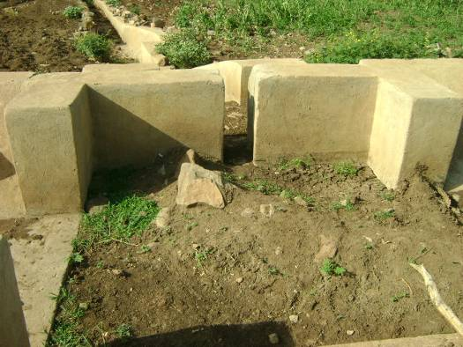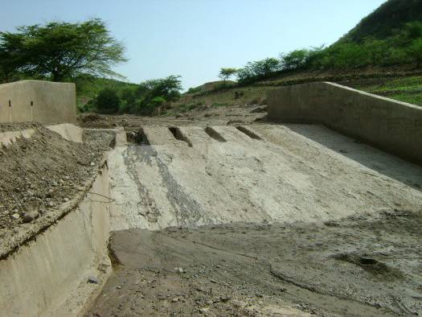
Figure 1 Division box on Bililo scheme Figure 2 weir on Bililo River

The modernized scheme was started before 4 years by initiative of local farmers and district experts. According to the respondent of the area the command area was simply understood by the local farmers’ agreement and during the improvement time there were discussion with Engineers and the command area become increased to 700ha. As it is experienced in developing spate irrigation in most of the area of the country potential of the river was estimated by farmers experience of water bank and the head work was modified to discharge the excess flood that is expected to come in 50 year return period. Accordingly, the maximum flood for 50 years Return period was 110m³/s.

The scheme was previously designed for conventional irrigation purpose and after losing its potential the structure planed to spate irrigation. This was the 1st and main improvement made to the scheme by the then Oromia Irrigation Development Authority.
In between the 1st and the 2nd irrigation system the farmers were not using this water except for those at head up to the day improvement added other farmers to the system.

In this scheme most of the time farmers don’t profit from the structure as per the design made during improvement. Less knowledge of spate irrigation system by farmers, DAs and by district experts and Problem of changing privies experience of farmers are considered as main causes for such failure.

Due to the above problems in the scheme network the water is not properly reach on farm and get the targeted objective, instead it flows along the main canal to other PAs of Saro and Bakka, which are not part of the command area.

Generally when we observe the watershed productivity from the incoming water it is very good and giving enough water to the area but the main problem lies in distribution of water to the farms and water application system to the farm.

As it is observed farmers of the area are living in water stressed condition and when there is flood they irrigate there farm in furrow system as they experienced during the conventional system in the meantime the flood may decrease with out satisfying the required water depth. Farmers irrigating “chat” plant doesn’t face such a problem they prepare there land before flood coming and simply led the coming water to the needed furrow (ketara).

4.1.1. Management and Operation

The scheme is managed by committee elected from WUA and selected manager Malaka (Mellaqa).this committee is responsible for all works related to scheme.

The members of water user by removing silt from the canal and inlet (off take) makes local maintenance every pre-farming season. Desilting practice is sometimes simplified because of the washing potential of the high flood.

If any association needs to use water from up stream of the diversion structure directly the malaka collect the committee and discussion will be made with the presence of DA. then the requested body may get or loss what asked before according to the pre requisite set by the committee. Such trained helped the association to increase confidence on there committee.

Malaka always leads the committee and work together. This committee performs the following main task.

- Prepare schedule for user
- Take care of the system
- Initiate farmers for maintenance and silt removal work
- Accredit new water abstraction with development agent
- Solve any water related conflict
- Report to District problem beyond their stand
- Call farmers for discussion and lead the discussion too.
Because of improper use of water on farm the expected result is not still obtained in the area, following this problem the committee as well as the WUA are not seen while dealing with the problem, when they give reason for such problem it shows that they do not know there right and duties and the awareness problem created due to the frequency of the development agent exchange by other new one.

Rights and duties of the WUA in Bililo scheme is not yet documented and available in hard copy and soft copy but it is understood by every member. Here are some of them from respondents:
Rights Duties
- Getting water at the right time Accepting penalty by committee
- Giving comment on discussion participating on meeting and works
- Getting water per schedule Contributing materials for maintenance
- Passing his/her schedule to relatives reporting any damage on the scheme to committee
In the main season the committee sits to schedule the coming flood to distribute to the members, while working schedule they take into consideration some of the following
Water stressed farm, location of farm, crop type, crop stage, farmer status. Priority to farm located at the tail of the scheme, of this for farm cropped with less drought resistant crop is given.

Here in this scheme farmers understand sediment in two ways before farm and after it reached on farm, before it reach on farm it is waste it adds other job on there permanent job but when it reached on farm it gives two use as moisture conserving structure and as fertility increment.

4.1.2. Sedimentation in Bililo scheme

Mostly the fine sediments reach to farm of up stream in suspension form with in flood along the main canal, secondary and tertiary canal to the fields, where they settle. Some farmers welcome sediment deposition on the fields as it provides fertility and builds up deep soils with a good water-holding capacity.

The coarser sediment fractions and boulders including debris are the important problems of the area following the problem of scheme due to the presence of un - completed water get and under sluce.
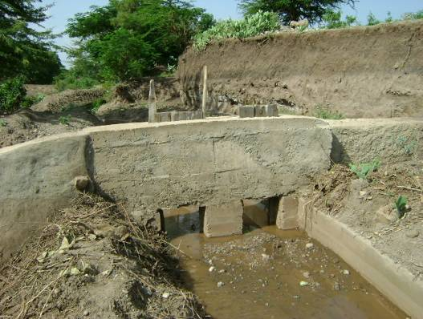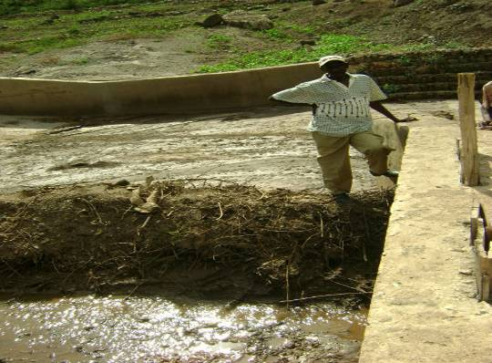
Figure 3 unersluce filled with debris Figure 4 water get included at Bililo

4.1.3. Rules and Rights in Bililo scheme

It is clear that the availability of water distribution and water use right regulates access to water and hence minimize conflict, but there are no as such strong rules of using water; it is observable by every one that farmers at up stream benefit more than those cultivating down stream. As it is learned in other country practice rules to regulate the distribution of spate water following the varying quantities of flood water are seen in some extent. For example farmers breaking field canal and main canal as well as other structure are transferred to district police by co-ordination of leaders and minisha (local police). Once farmer started to irrigate s/he have right to continue till his farm get water well, most of a time it may be up to 2 and half un hour. If there is big flood farmers at the tail may also get the chance to receive flood since no one can divert the whole flood and farmers at down steam simply wait for large flood they don’t have any complain in up stream user.

4.1.4. Field Water Distribution Strategies

The nature of spate irrigation means that farmers cannot follow a predetermined irrigation schedule where water quantities are applied to a crop when it is needed. Water distribution is regulated by prevailing water rights and water distribution rules and generally seems to follow a number of principles (Lawrence P and F .V. Steenbergen, 2005). Water to all farm is supplied as conventional irrigation system, the water flows above the field and the farmers abstract it for there purpose.

4.2. Waltane Traditional Spate Irrigation Scheme

It is found 25 km at the eastern part of the district town mi’eso, and developed before 27 years by initiative of the local farmers. Consisting of deflecting spurs, earth filled canal, cut canal, flume and field canal to supply water to fields directly. The whole system is managed by farmers with out any support from out side except for assistance by DA. of the PA. These farmers are using different local material to divert the river and to stabilize the river bed and river bank including stone, wood, sand filled sac.

The area irrigated with this scheme is increased year to year, according to the development agent Mr. Ephrem in good season the total command area increased up to 200 some times up to 250 ha. But in normal time (rain type which is experienced for a long time) it irrigate up to 150 ha.

As it is informed by the farmers it is common for those people around the river bank to use the water as supplementary to rain during rainy season. Since there is no flood problem to water there farm in good time the farmers do not complain additional water diversion up stream of there diversion.
µ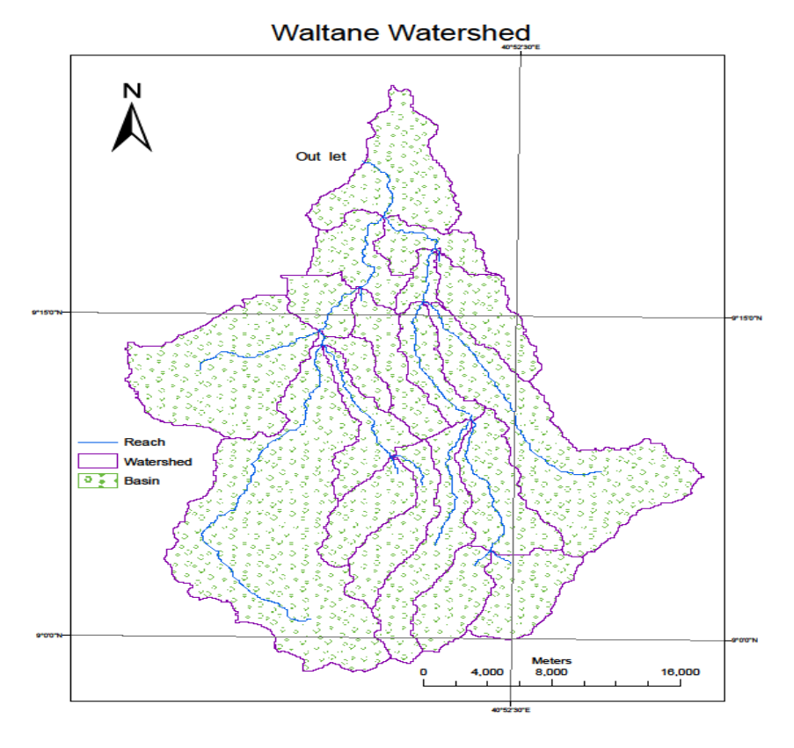
Waltane irrigation scheme watershed

Waltane River is drain from chiro (Asebe Teferi) and Doba district high lands, and flows to Awash river through low lands of mi’eso in northern part of the district.

The construction work of the scheme was started one after main flood and stayed for the whole flooding day then for the next time started after passing the main flood this was continued up to the completion of the main canal work. The reason for this group to wait recession flood for constructing canal is that they use the flood as a guide since they have no instrument to aid there construction. Farmers follow water at the deflector and give way slowly by checking the direction they are interested this made the water to flow to long distance. In some places where there is natural obstruction farmers pass by applying local knowledge and local material, this skill is seen by flume constructed over water way in between waltane river and command area.

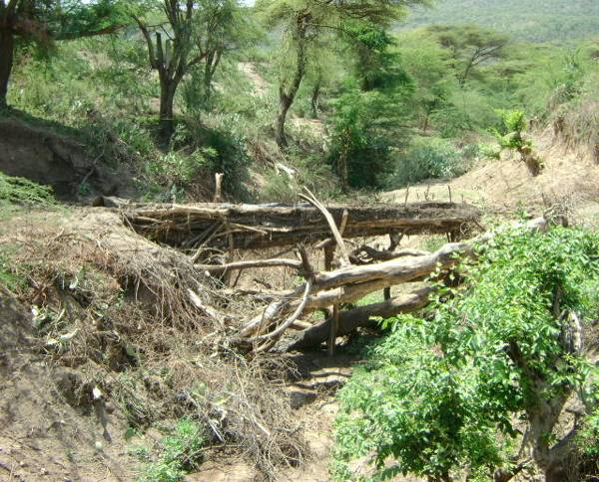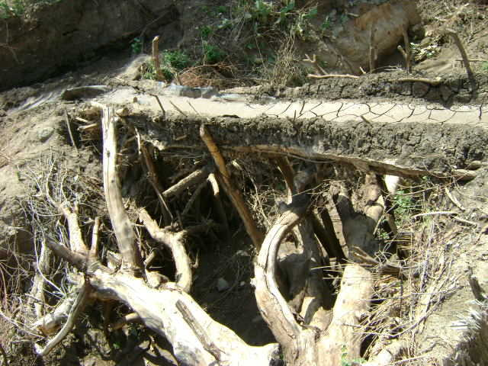
Figure 5 Traditional flume at Waltane spate irrigation system

4.2.1. Management and Operation

As it is seen at Bililo scheme most of the practice are similar, the scheme is managed by committee elected from WUA and selected manager Malaka (Mellaqa).this committee is responsible for all works related to scheme.

There are 3 large diversion structures are constructed with there own WUA and meleka. The 1st diversion irrigate the left side up to 3km down stream, the rest two are irrigating the right side of the river.

Maintenance work is facilitated by co-ordination of each Melaka. As it is development the 1st is the one at down steam and the middle and finally the upper one is developed. The latest diversion is constructed to irrigate the mosques farm located above the two diversion structures but there are other farmers using this flood after irrigating the mosque farm.

The members of water user by removing silt from the canal and inlet (off take) makes local maintenance every pre-farming season. Desilting practice is sometimes simplified because of the washing potential of the high flood.

If any association needs to use water from up stream of the diversion structure directly the malaka collect the committee and discussion will be made with the presence of DA.then the requested body may get or loss what asked before according to the pre requisite set by the committee. Such trained helped the association to increase confidence on there committee.

Melaka from the three diversion some times collected and discuss on general flood using system in the other time they make informal discussion when they meet in spiritual ceremony, administration purpose and in any occasion. Since this peoples are almost all are follower of one religion (Muslim) they have the chance to meet frequently and to know each other there fore they have no problem in selecting committee or abba bishani (Melaka). Here the WUA and the committee perform equally and the same to the remaining two improved schemes that is; always leads the committee and work together.

4.2.2. Sedimentation in waltane scheme

Sedimentation in this scheme is not considered as problem for the whole production, since the recession flood is used as irrigation water large and medium sediment is not significant but small suspensions in flood dropped along the canals.
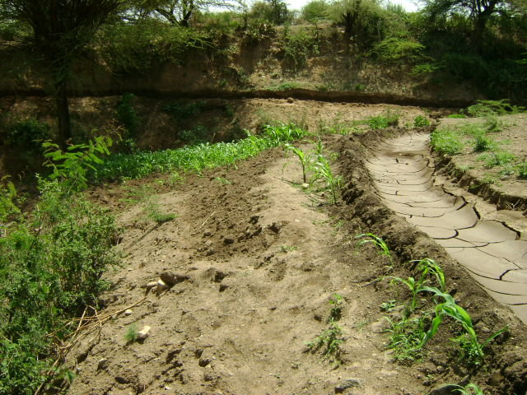
Figure 6 Sedimentation along main canal

4.2.3. Rules and Rights in waltane scheme

As it is seen in bililo scheme also in waltane there is no written rules simply peoples agree and disagree on issues raised by Meleka of respective schemes, the meleka discuss every agenda (idea) with the committee members before bringing the issue to the association. The committee members are of five members including the DA in that PA and health extension worker, the DA and health extension workers are committee member in all the three water user association this helps the farmer to share any of good news and experience through these peoples.
Some rules and rights which are common in other countries are practiced here traditionally for example;
- Whatever priority is given to the up streams the down streams are also have right to abide the up stream farmer from developing additional land. But this is impractical because till now there is no water shortage reported by down stream by additional of land at up stream.
- If flood water reach there down stream farmers have right to extend there farm as they wish but they have no right to ask additional water for this extended farm if shortage is created.
- Field canal mostly irrigate both right and left side farm simultaneously, farmer down of the irrigating farm needs to wait while the up stream irrigating his/her farm (if the flow is less).

4.2.4. Field water distribution strategies

Water distribution in spate irrigation system is mostly practiced in two different ways, in countries having long time experience and with large scale farms on level land water distribution is made field to field system flood come to the 1st farm and after satisfying the needed depth of flood on bunded farm it flows to the next and then to the next most of a time a depth of 50cm is common. In the other way flood is provided with a net work of canals so that flood can be reached to every farm. Here in waltane following the size of farm, slope of the land and experience from the previous irrigation practice of conventional irrigation system the later practice is practiced.
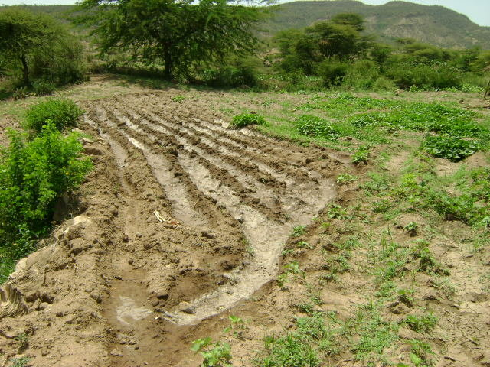
Figure 7 Furrow type water application practice

4.2.5. Maintenance and Rehabilitation

As it is known spate irrigation needs group work in advance than conventional irrigation. When we see the traditional spate irrigation system it needs further more co-operation than any of irrigation system, because the flood which come to the head work is un expected with shot time duration.

Waltane is a traditional spate irrigation system which is started before 27 years; the farmers of the area are experienced with group work for maintenance works starting from the beginning of the scheme. All farmers of the area have responsibility to take care of the system and to participate in any rehabilitation or maintenance work.
In waltane maintenance and rehabilitation works performed by initiative of Melaka and by participation of WUA includes

- Maintenance of diversion structure after it is removed by flood
- Maintenance of main canal to avoid water loose and to prevent from breaking
- Stabilization of river embankment
- River bed stabilization
- Maintenance of canal structures like flume

Other maintenance work related to such as field canal is carried out by the farm owner.
While working the maintenance and rehabilitation work they need different local tools like Mencha (to cut trees and to prepare peg), spade (to collect sand) and hammer. In maintenance and rehabilitation work they used locally available materials like sand, stones, woods, sacks and others.
In such traditional spate irrigation system damage of structures is very common and occurred repeatedly, this structure failure is mainly occurred by large flood during rainy season and by animals during non rainy season.

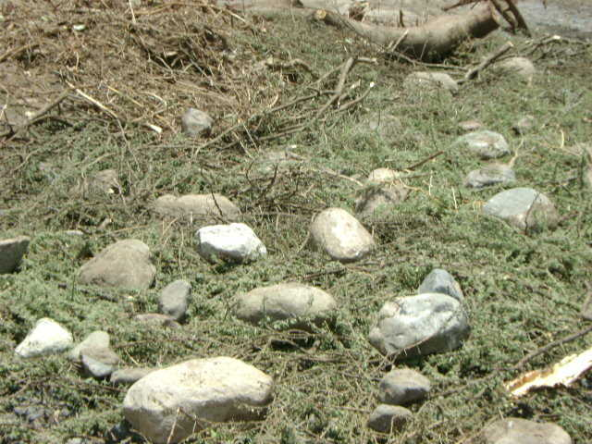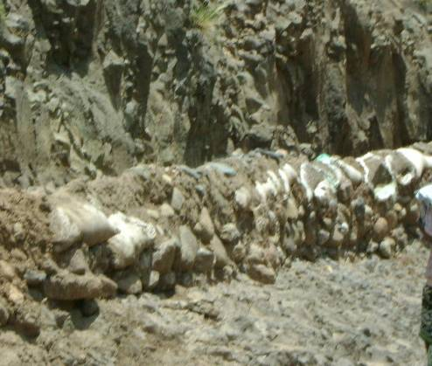
Figure 8 River bed stabilization at waltane traditional spate irrigation Figure 9 Canal construction

Other practices in weltane

Farmers family living near by this river get water for there livestock, drinking and domestic use from this river. During rainy season they finch water and add in selected soil type to distil the suspension found in the water then they use it to drink and for home consumption. In other time when there is low flow in the river bed they dig the alluvial soil at the bed of the river and collect water for there home and to the livestock. Here are some pictures showing using water under alluvial soil for home use.

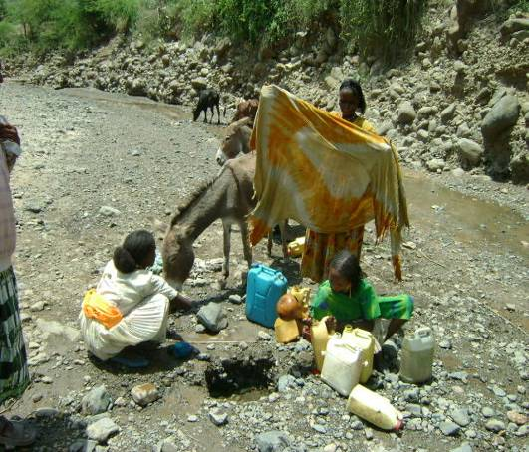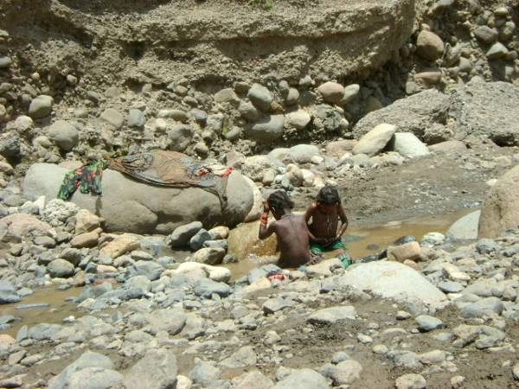
Figure 10 Water for domestic use and bath in waltane

4.3. Hargeti Modernised Spate Irrigation

This scheme is located around 47km south west of the district town Mi’eso,8km from Kora village, the GPS reading of improved weir shows 37p0675368,1001205 it was developed before 4 year by initiative of farmers. Before the improvement the farmers were using the water traditionally by abstracting using different mechanism, the farmers speak that they experienced diversion of flood using local wood stone and sand filled sac. In this scheme farmers have a good practice of production of different crops such as Onion, Tomato, Maize, Sorghum, “Chat”, Banana and Sweet potato are major crops of the local farmers practice. During rainy season they need to irrigate once but if there is no rain or less rain they need up to 3 floods for one production time.

There is no written document of the area rule and regulation but according to mellaka there are rules that every body understand it well, if one is not participated in maintenance work of 5 day he pay 50 birr, and if one take water with out schedule s/he get 100 birr penalty after spending one day in prison. The committee of this water project includes two elders, One DA, One Health extension worker and Two Mellaka (one for each division) a total of 6 members.

The farmers having holding in Hargeti scheme live out side the scheme area in three villages Hargeti, Kinteri and Kora. The number of households in the area is not known it increases if there is enough flood and decreases if the amount of flood minimized. The ethnic of beneficiary population are all Oromo and largely they are Muslim. These groups are depending on agricultural activities (mixed farming system with ox-plough culture) as major source of income. Major crop grown are cereals such as maize and sorghum. The main livelihood system of the inhabitants depends on livestock and crop production. Crop failure as a result of insufficient rain fall was common. Generally the sole rain fed crop production was in sufficient and as the result the residents were used to receive relief food assistance very frequently before the improvement work.

The command area slopes to northern direction with slope ranging from 2 to 5% which reduced to wards the river (Arba River). During development of scheme the area were dominated by grazing land but with in this shot period currently the area is totally covered with cultivation of different cereals and cash crops which shows the need of water by farmers for agriculture than livestock production.

According to the design document the catchment area is estimated from quarter million topographic map and found to be 82.26 km² with a watershed perimeter length of 60.5 km. The river emerges at the southeast and flows to North West direction.
The document also explains that the catchment highest elevation is 2000masl. And the lowest is 1290masl.
The flow from this river has a sound suspended load especially during the beginning of flood time.

During design time it was planed to construct head work with 50 year live period, and flood is estimated on probability theories and adjusted for specific embryologic factors.

Organization and Maintenance

Regardless of the size of the scheme and the nature of the system it is difficult to act alone. To distribute the available water according to the season to the local farmers they have to participate in maintenance work there fore the existence of organization was very necessary. This organization developed to association after the improvement of the scheme. During election for there association management skill, devotion for others and relation with community were the key points. The management skill includes organizing group of farmers for maintenance when necessary, resolving conflicts, Organizing and delegation of responsible person for daily distribution of water in different part of the schemes.

Here the WUA included all works necessary to keep there system operating some of this are, cleaning of vegetation from canals and drains, repairing embankment, removal of silt and boulders from canals and at head work.

The organization of this system is well organized as WUA which include all farmers from the scheme benefiter. they have unwritten water right and rule, the farmers in tertiary units (TU) are collectively form water user team (WUT) who organizes the rotation of water to there TU. In all technical matters of operation as well as maintenance work Development Agent (DA) of the two PA and the district Irrigation expert help them.

WUA tasks
- Maintain water right of the scheme
- Ensure conveyance and distribution of water to the farm unit in accordance with agreed delivery period.
- Organizes maintenance works, acquires the required materials and fix contribution for such problem.
- Establish frequencies of maintenance and tasks of water user
- Conclude the necessary local skilled or unskilled labor
- Make any decision on operation and maintenance also other internal and external problems.

Water user Rights
The water users have the right to elect their tertiary unit leader(TUL). The TULs elect the head of WUA(meleka) The water users have right to get all services provided by DA and district experts including
- Technical assistance on farm management and other activities
- Access for inputs by dealers or government(fertilizer, pesticide, seed, etc)
- Execution of farming activities, plowing, fertilizer, pesticide application.
Water user duties
The scheme is developed for the benefit of farmers by initiative of farmers however there are some farmers who are not using the scheme facilities properly and there participation in improving and keeping the project life for a longer period is not satisfactory, there for the fallowing duties are set
- The farmers are obliged to avoid all possible form of water loss
- The farmers are obliged cooperate in labor and in financial requirement for maintenance
- The farmers are obliged act in accordance with schedule of water delivery established by WUA
- The farmers are obliged maintain properly the scheme

µ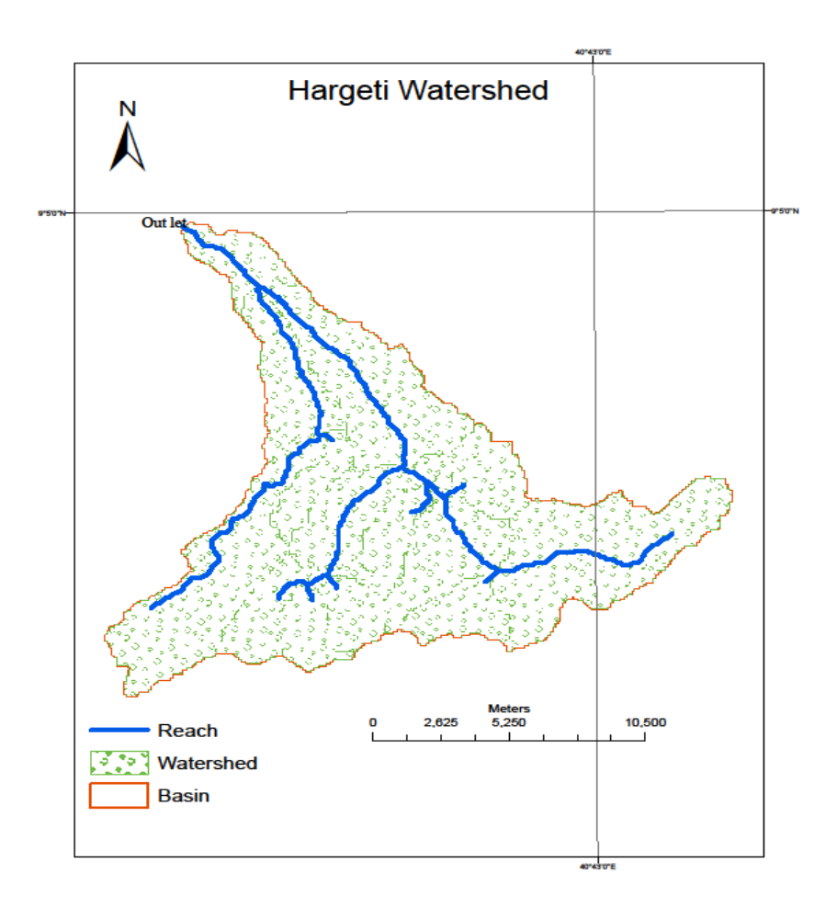
Hargeti Spate irrigation watershed

The weir is constructed across Arba River which drains from high lands of Gubakorcha, Kuni and mi’eso district.

To secure sufficient and reliable supply of water to the scheme during irrigation the existing traditional diversion structure was improved by Oromiya water works and supervision Enterprise before 4 years.

When the scheme is designed it was planed to abstract water in both right and left side of the river but now a day only the right side construction is completed and starts to serve the local farmers. 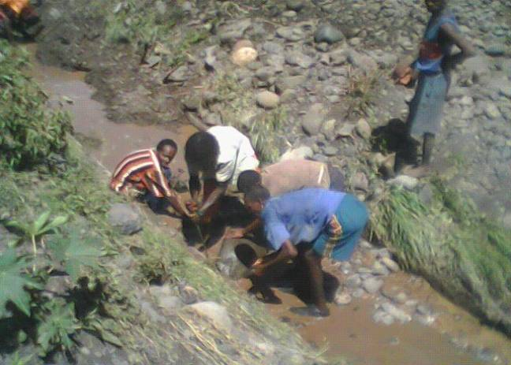
Figure 11 Hargeti and kinteri farmers clearing main canal

5. SUMMARY

The purpose of this paper is to document the spate irrigation practices in eastern Ethiopia especially in West Harerge Mi’eso district. The paper included three schemes in the same district of which two are modernized spate scheme while one is traditional. While preparing the document primary data was collected by the district development agent (DA), secondary data was collected from the district office, the designers, presentation made at Haramaya University in 2009 and respective offices.

Due to the fact that rainfall in lowlands is low or even stops before harvesting can begin, farmers in such area created barrages made of rubble, boulder and sand sacks where there is no structure made like waltane so that they add flood to their farm as supplementary to rain. Once the dark rain clouds start gathering up in the mountains, they know that the river will come with flood after some days and start to prepare there lands some start to plant other cultivate there farm repeatedly to loosen the soil for good seed bed preparation.
Here Hargeti is considered as partial spate irrigation because flood keep on for long time relative to the other spate system, while Bililo and Waltane are totally mentioned as spate irrigation, they have flood property.

In the district there is no attention given for the water works in relation to irrigation, simply the district experts and the administrator body talk about the presence of the structures, no one knows about its efficiency, failure, strength and productivity of the schemes except report from DA. Farmers irrigate their farm according to their experience from the late farmers no improvement is done from experts and development agent. According to the respective DA this is raised from lack of knowledge, training is given for district experts and they do not transfer it for concerned persons (DA). There for it is understood that the failure of Bililo spate irrigation to came up the designed objective is caused from failure to know how to irrigate flood to farm and when to irrigate it and how much to irrigate it. The success of Hargeti is gained because of the nature of flooding time it flow longer time than in Bililo, in this scheme also there is no good knowledge to irrigate farm properly, while Waltane traditional spate irrigation gained the success due to the whole system is designed, constructed , managed, and implement by the farmer it self and no interference of other people there is no confusion made on farmers they act according to their understanding.

6. LOGISTICS

The logistics required to under take this study is detailed as shown hereunder.

5.1. Budget Break down
No | Item | Unit | Quantity | Unit price | Total cost
1.1 Printing and photocopy paperpkt885.00680.001.2 Field note bookpcs225.0050.001 | Stationary |  |  |  | 2,450.00
1.4 Toner cartridgepcs11,500.001,500.001.5 Pen pcs202.0040.002Field equipment expense200.00 | 1.3 Compact CD(RW) | pkt | 1 | 180.00 | 180.00
Personal Expense4,500.003.1 Student per diemdays2070.001,400.00 | 2.1 Field bag | no | 1 | 200.00 | 200.00
3 | 3.2 Field assistant per diem | days | 10 | 58.00 | 700.00
Travel and supervision Expense5,662.504.1 Fuel for Motor cycle lit10014.001,400.00 | 3.3 Data collector (per questionn.) | No | 60 | 40.00 | 2,400.00
4 | 4.2 Lubricant | lit | 3 | 47.50 | 142.50
 | 4.3travelto mi’eso & Addis A. (bus) | trip | 14 | 80.00 | 1,120.00
 | 4.3 Supervision fee | LS | - | - | 3,000.00
4.1 Communication(mobile card)LS2000.004 | Miscellaneous expense |  |  |  | 2,000.00

6.2. Budget summary
SN Description Total cost (birr)1Stationary2,450.002Field equipment expense200.003Personal Expense4,500.004Travel Expense5,662.505Miscellaneous expense2,000.006Sub total14,812.50

7. REFERENCES

Alemayehu, T. 2008. Ethiopia spate irrigation country profile. Addis Ababa, Oromia Water Works Supervision and Design Enterprise.

Eyob Yehayis 2009. Design Approach on Bililo Spate Irrigation Project Presentation at Haramaya University, Ethiopia.

Girma Mengistu, 2009. Roof water Harvesting for Domestic Water Supply. A Manual for Training of Trainers. Ethiopian Rainwater Harvesting Association.Addis Ababa, Ethiopia.

Haile, A.M. 2007. A tradition in transition, water management reforms and indigenous
spate irrigation systems in Eritrea. Leiden, Taylor and Francis/Balkema. Ph. D. thesis.Wageningen University.

Haile, A.M. (no date.). Spate Irrigation – overview guidelines.

Kidane G., Abebe T. and Degefie T. 2006. Estimating crop water use and simulating yield reduction for Maize and sorghum in Adama and Miesso districts using the cropwat model

MOA (Ministry of Agriculture), 1998. Agro-ecological zones of Ethiopia. Natural Resources
Management and Regulatory Department, Addis Ababa, Ethiopia.

Birhanu Kebebew and Mengistu Bose, 2007. On-Farm Assessment of Boru spate
Irrigation Systems. Oromia Irrigation Development Authority, Finfine, Ethiopia.

OgbaMichael, B. (no date). Agronomy in Spate Irrigated Areas of Eritrea. The State of Eritra Ministry of Agriculture Department of Regulatory services Plant Health Division.

Tesfa-alem G. 2009. Analysis of Spate Irrigation Sedimentation and the Design of Settling Basins. MSc Thesis UNESCO-IHE Institute for Water EducationWSE-HERBD-09.04

Tesfai, M., 2001. Soil and water management in spate irrigation systems in Eritrea.
Ph. D. thesis. Wageningen University.

Van den Ham, P., 2008. Dodota Spate Irrigation System Ethiopia. A case study of Spate Irrigation Management and Livelihood options. M.Sc. Thesis Wageningen University, The Netherlands.

Van Steenbergen, F., Haile,A.M., Alemayehu,T. Alamirew,T. and Geleta,Y., (no date). Status and Potential of Spate Irrigation in Ethiopia.

The World Bank Agriculture and Rural Development Department, 2006. Ethiopia: Managing Water Resources to Maximize Sustainable Growth. The World Bank
1818 H Street, NW Washington, DC 20433

8. APPENDIXES

8.1. Hargeti galleries

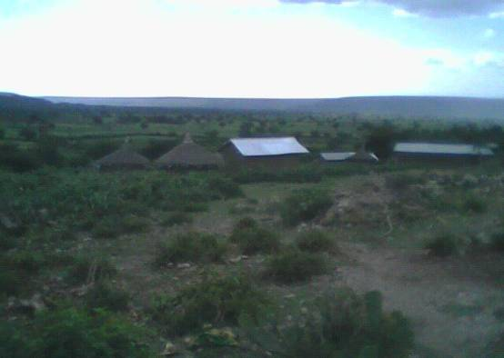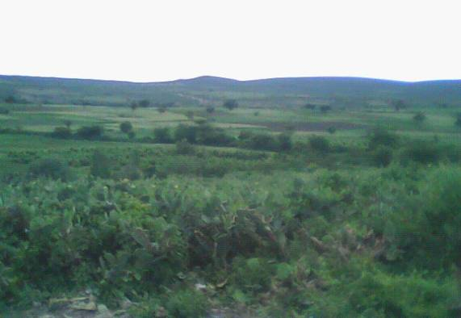
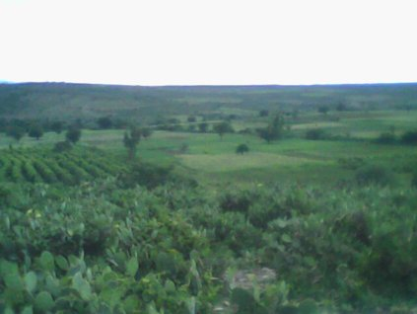

Command area of Hargeti Spate irrigation project, there are different crops production in this area which are explained in the body of document.

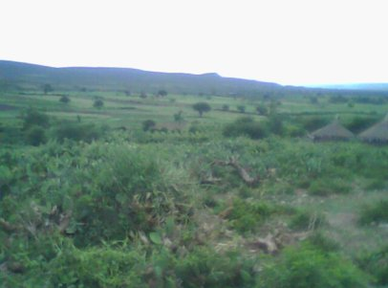
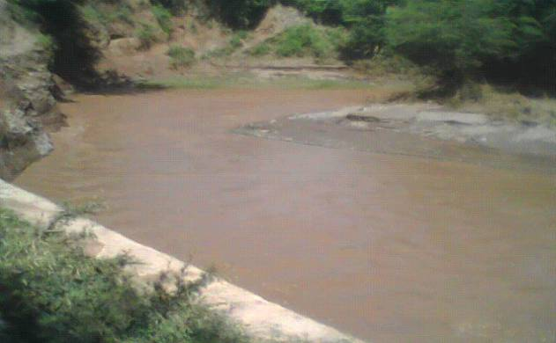

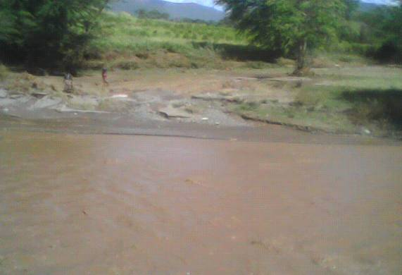 Flood reaching weir site comes with silt load and flooded farm at the side of the water way. 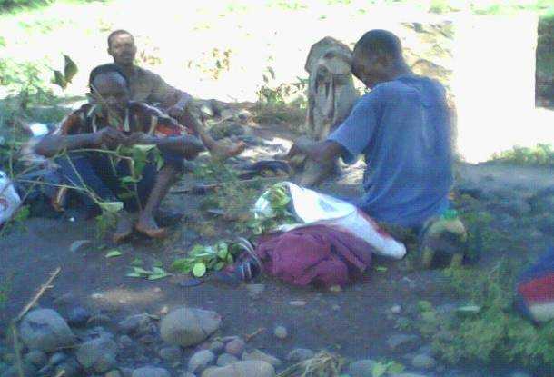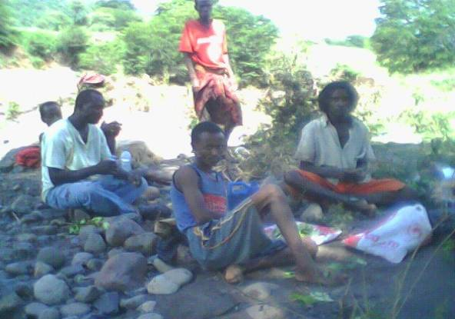Farmers preparing for maintenance work, they are chewing “chat” 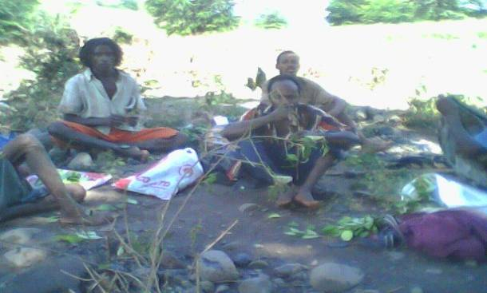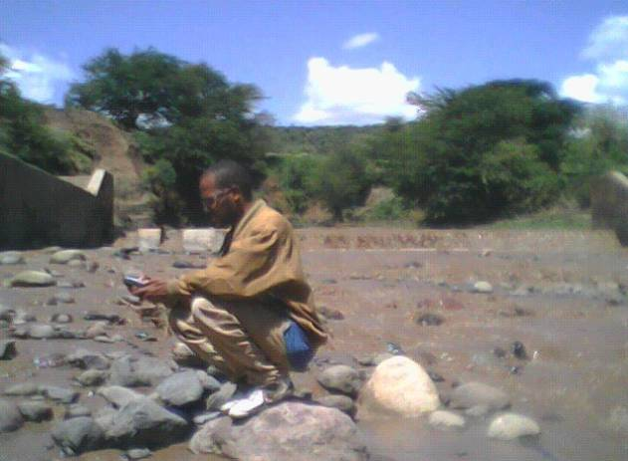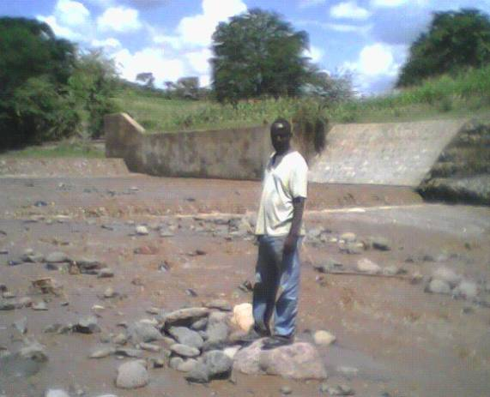Taking location with GPS. 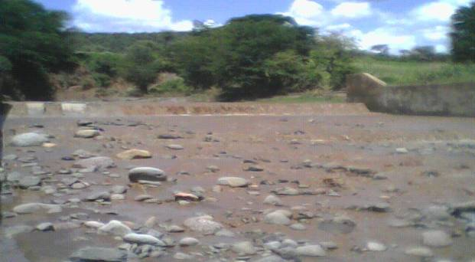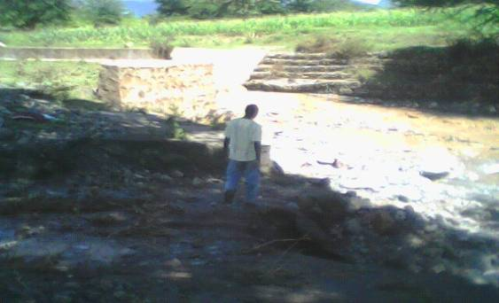Weir site of Hargeti project
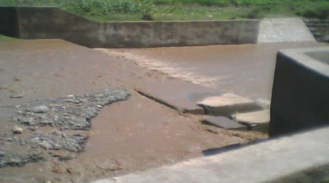
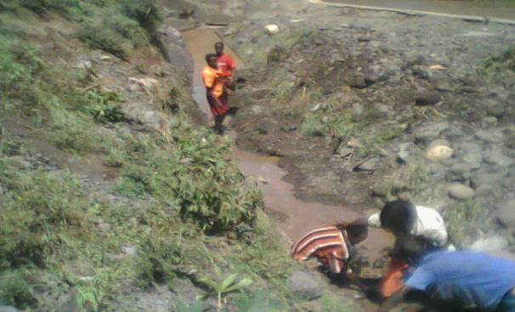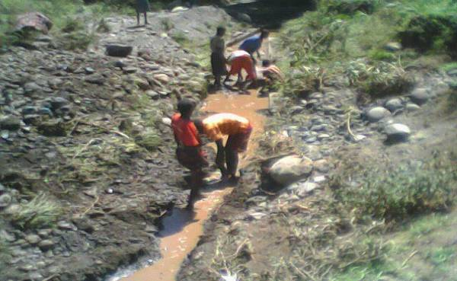Farmers removing silt and boulders from canal 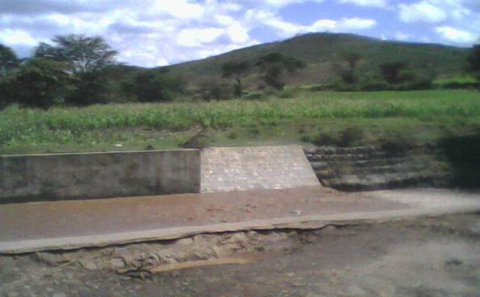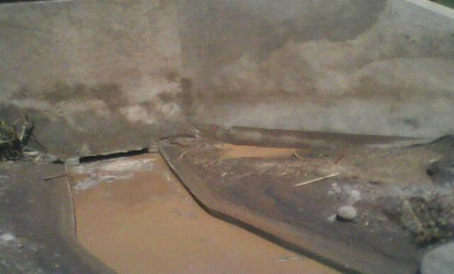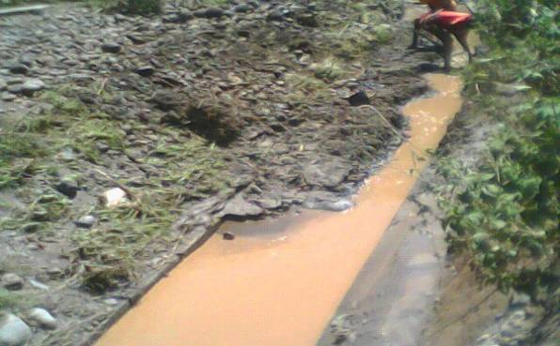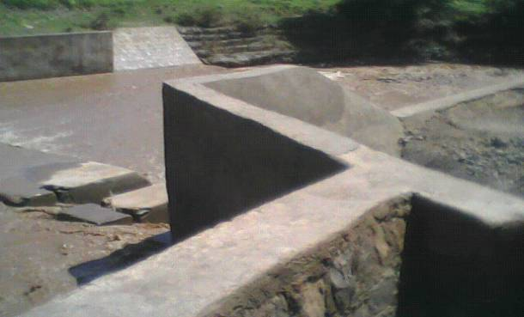

Net work of Head work

8.2. Bililo galleries

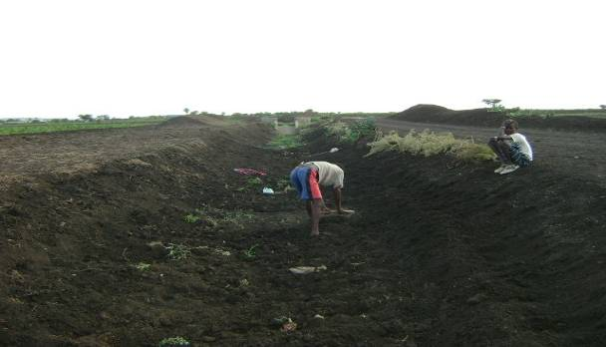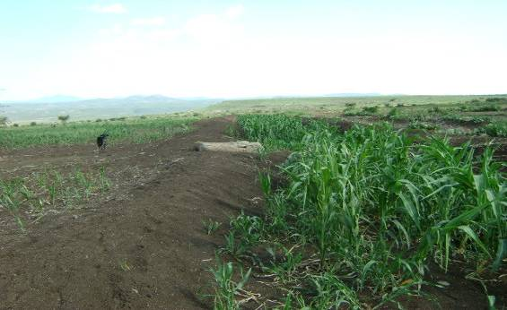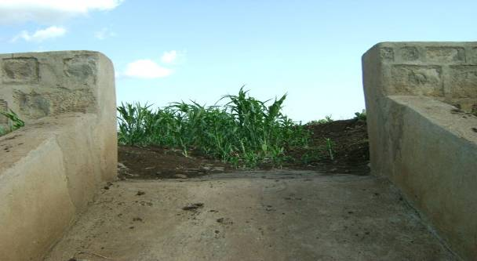Plantation in the canal of bililo spate irrigation, always farmers are searching for moisture so that they practice cultivating in canals.
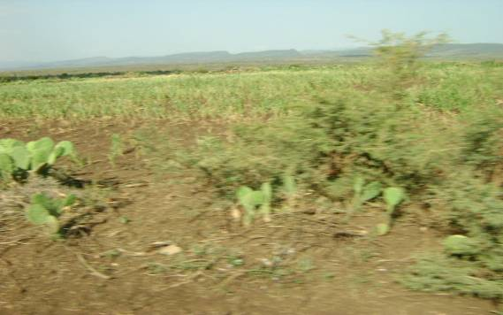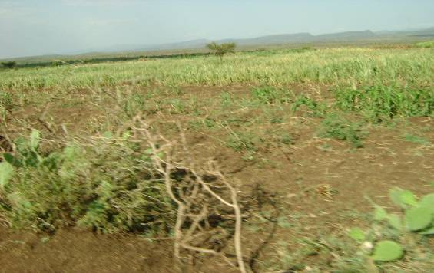 Command area of Bililo, the plant is seen water stressed because it lost to get enough amount of water from flood which is caused by improper water application system.
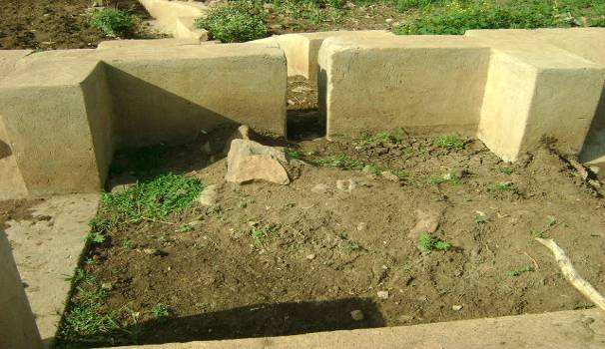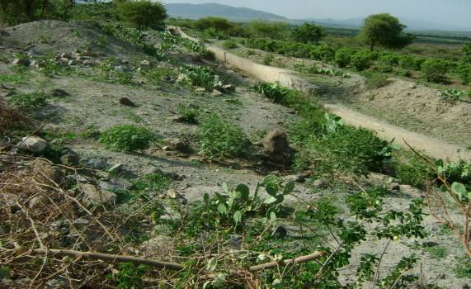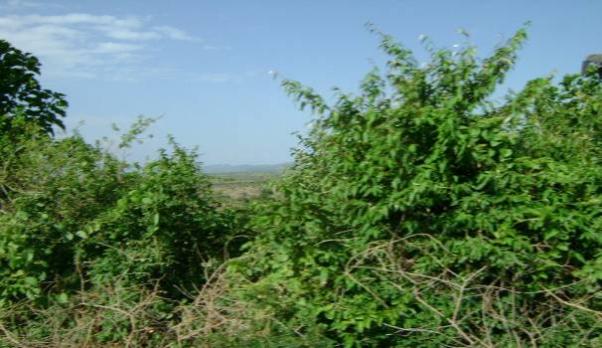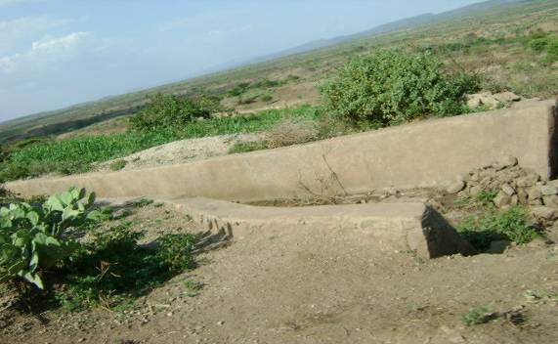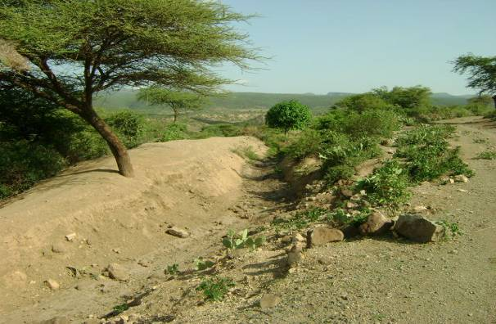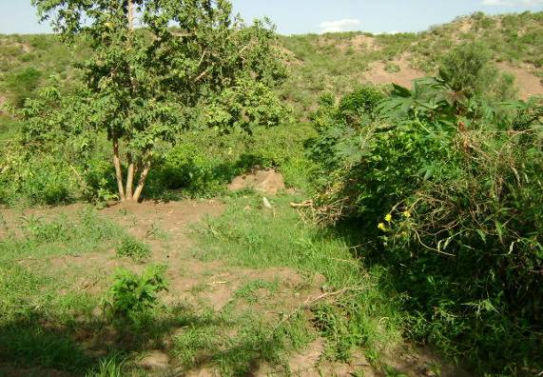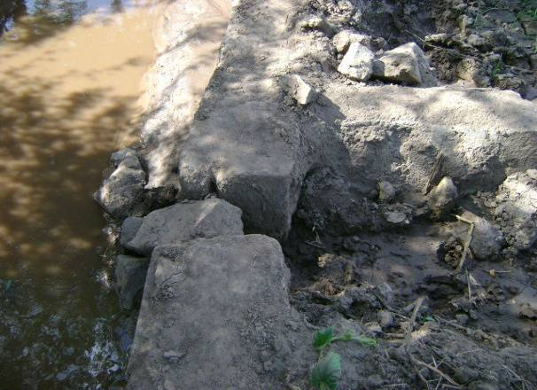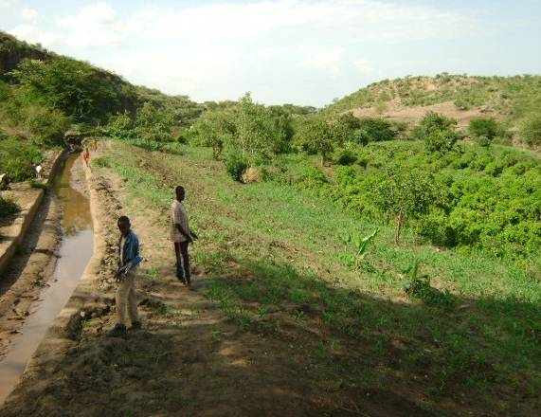 canal and canal structures in along the main canal 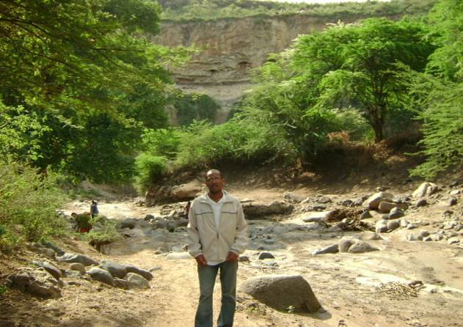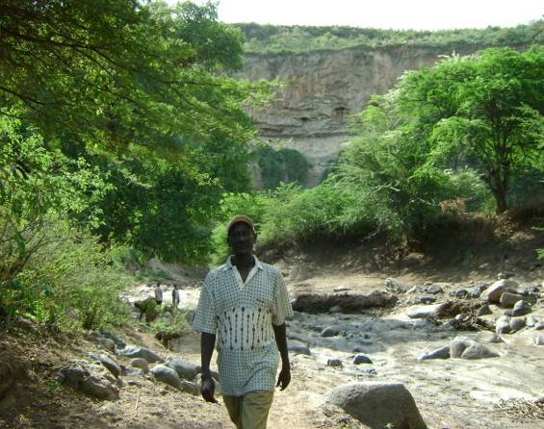Water way of Bililo river 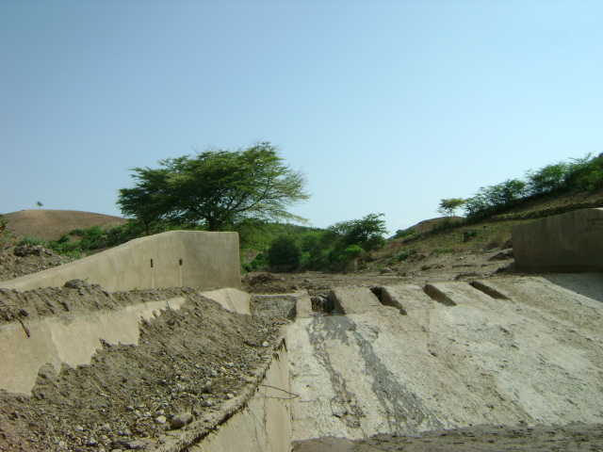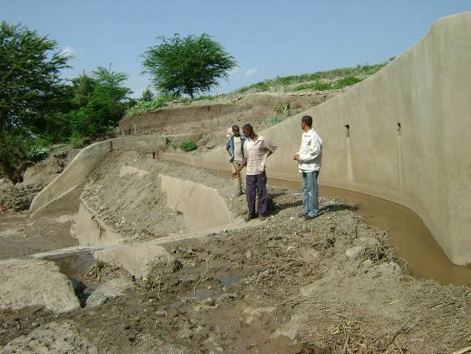Bililo weir 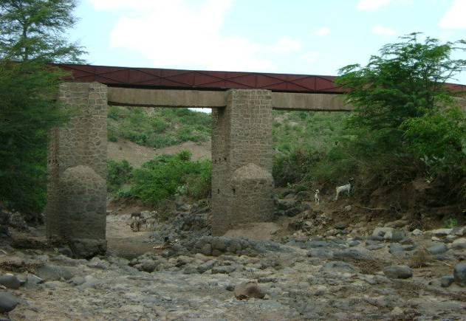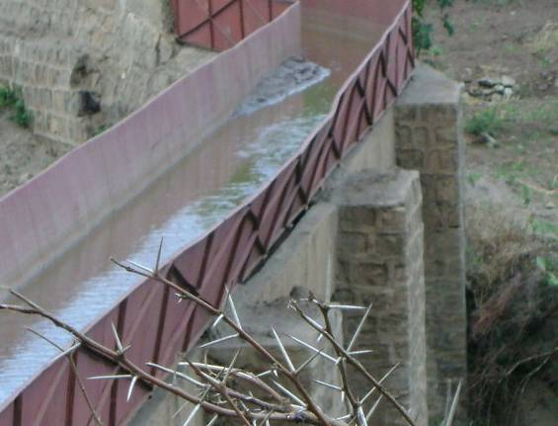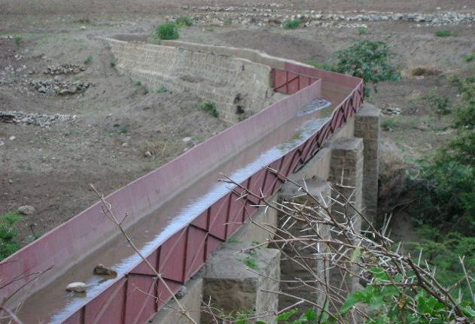

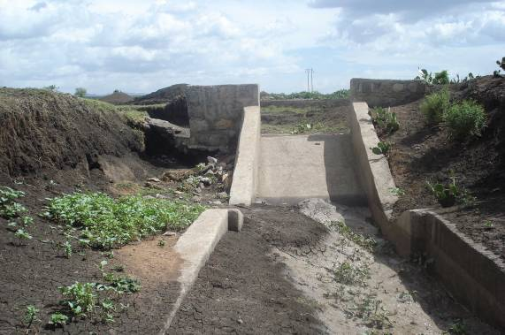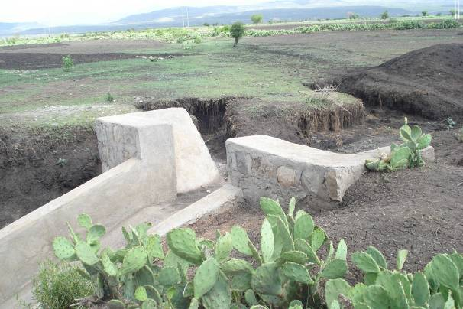 Drop structures need maintenance 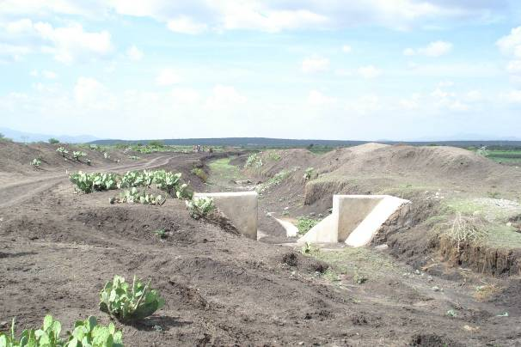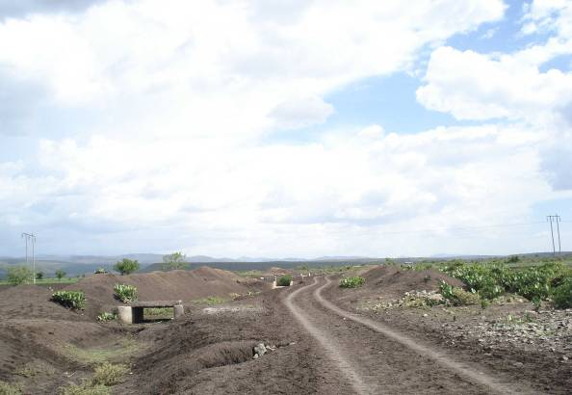

8.3. Waltane galleries

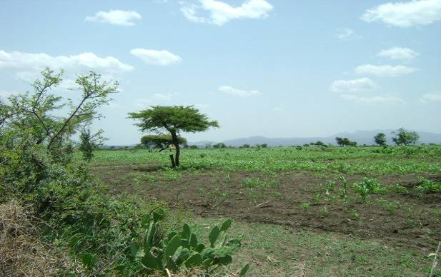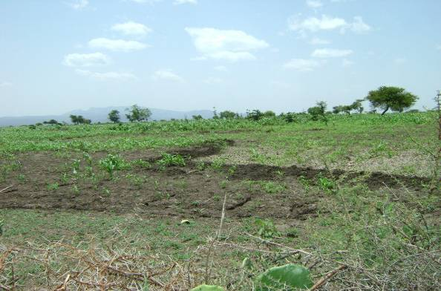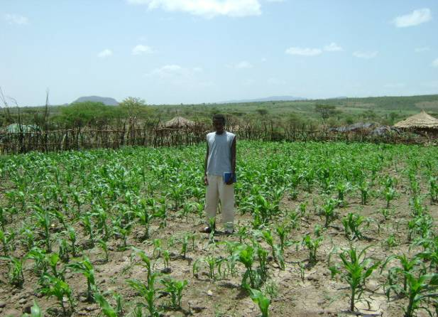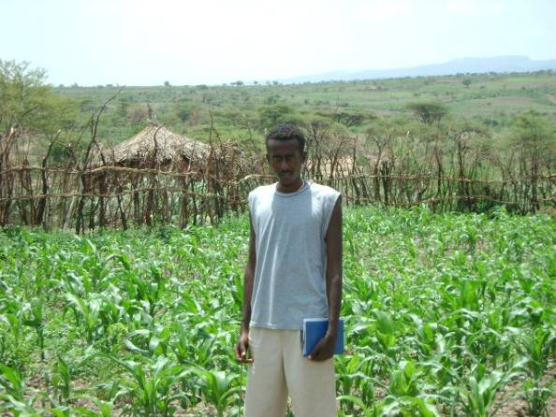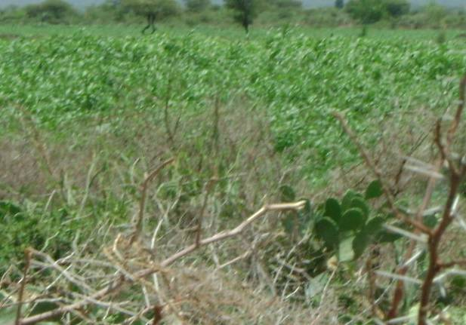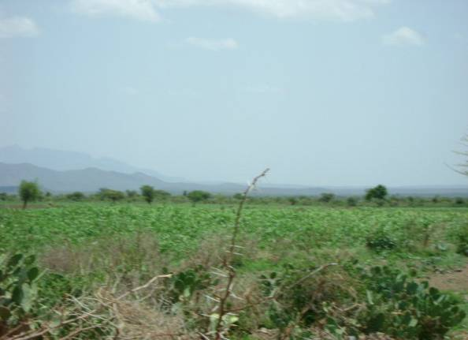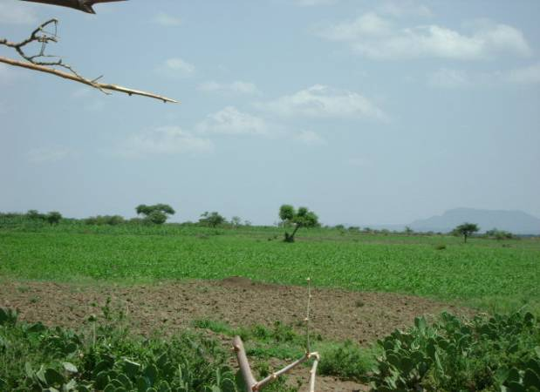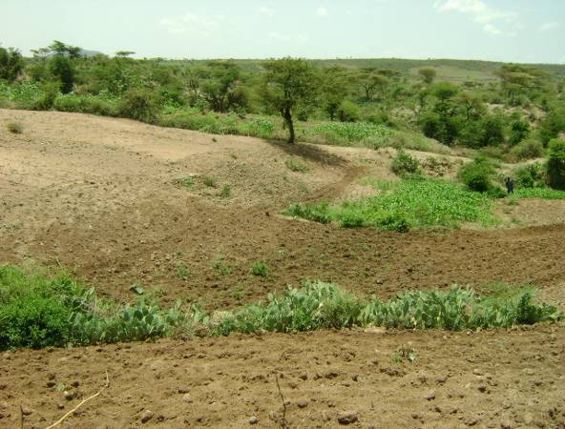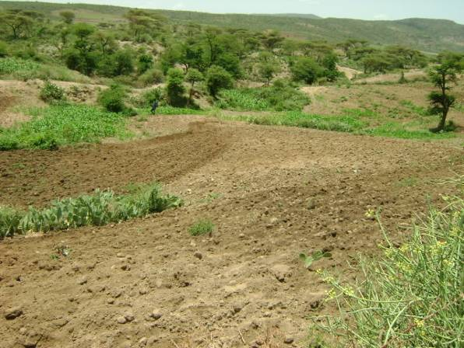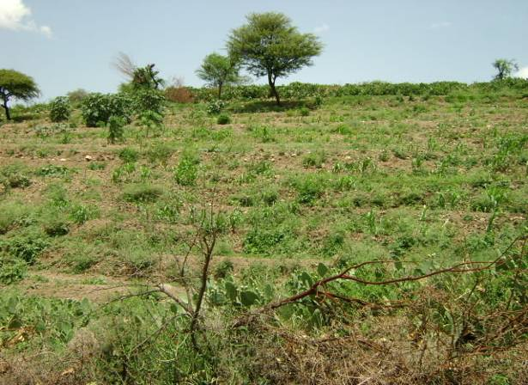Command area of Waltane traditional spate irrigation except for the problem with slope there is good practice than bililo this is due to the recession flow stays more than in bililo. 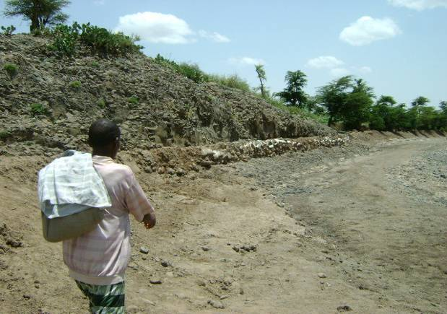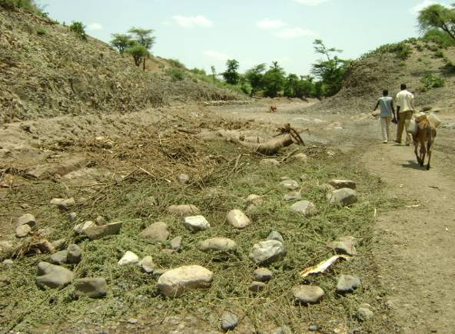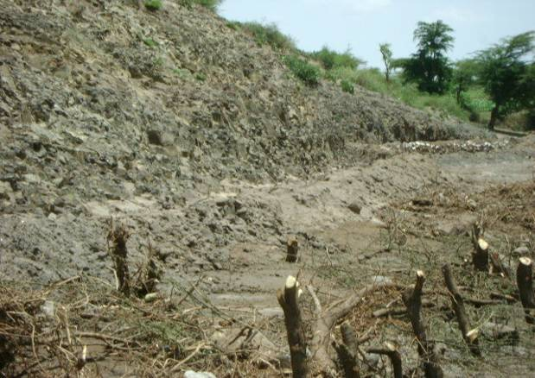
River bed stabilization and canal construction at diversion site to keep the elevation of the selected diversion site and to give there canal strength.

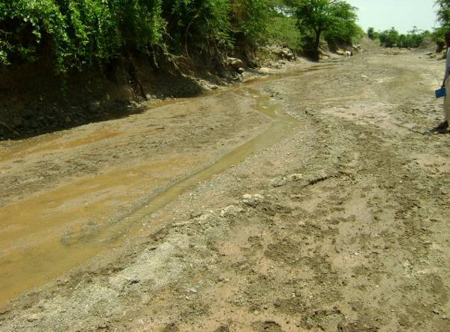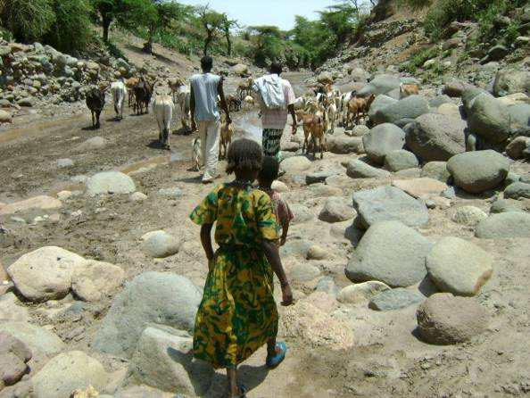
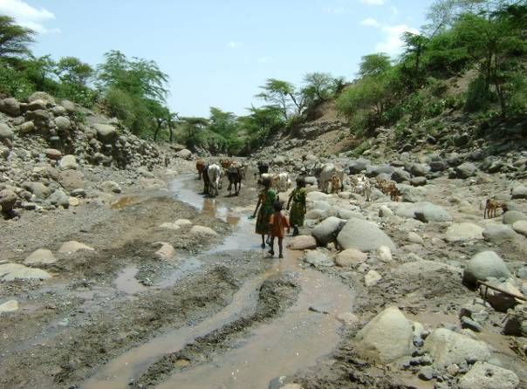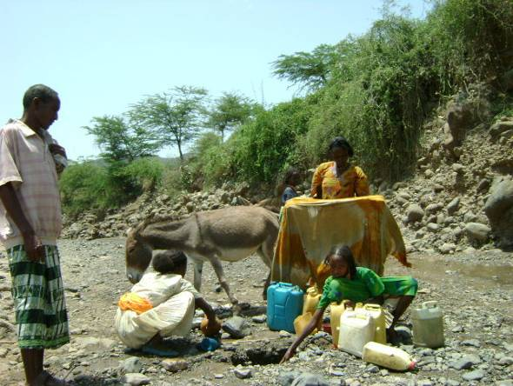waltane river 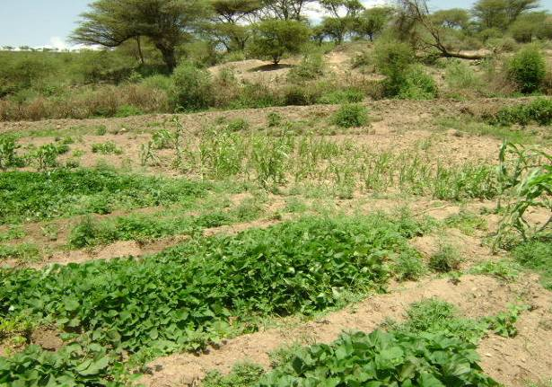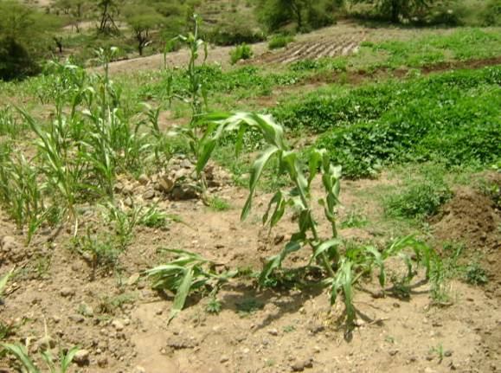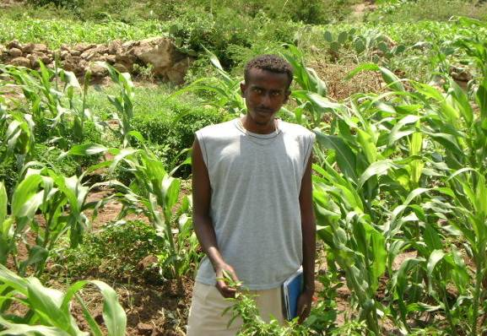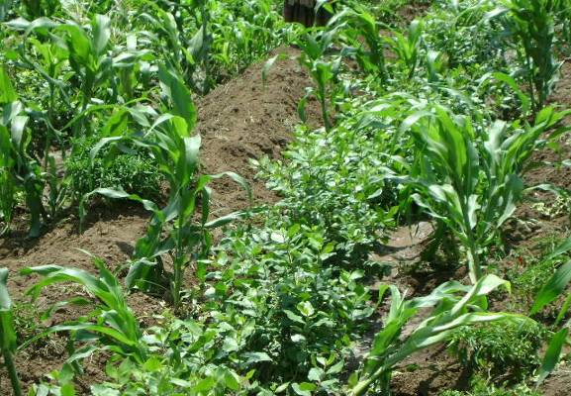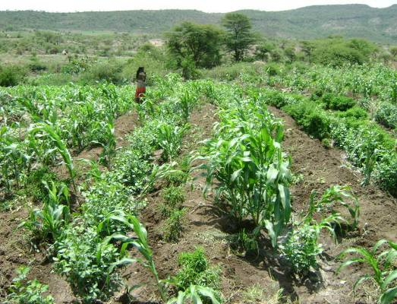 Irrigated farm and planted with different crop type at up stream area in this farm Maize “chat” green paper and sweet potato are planted. 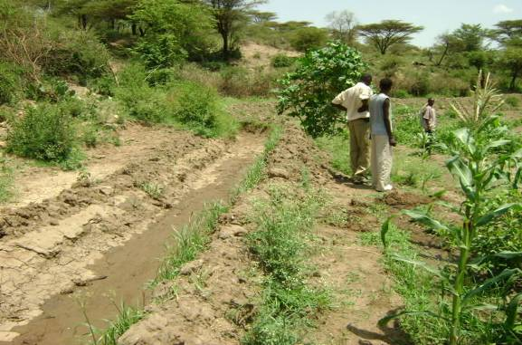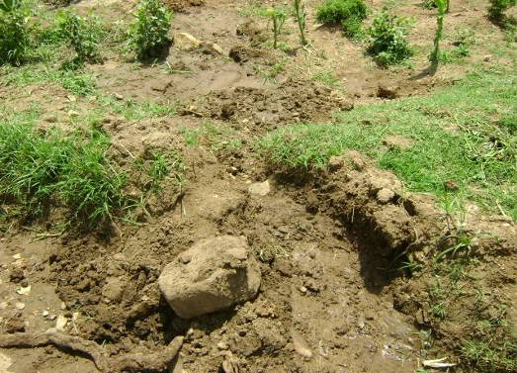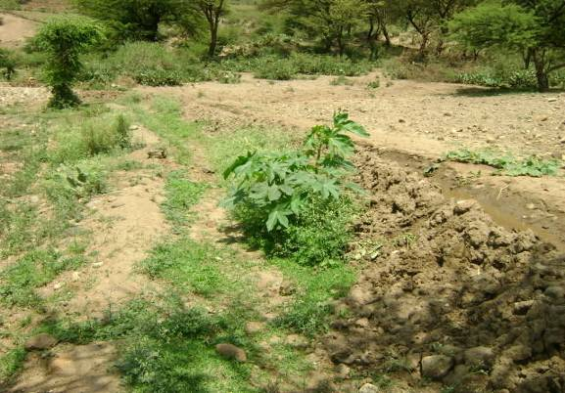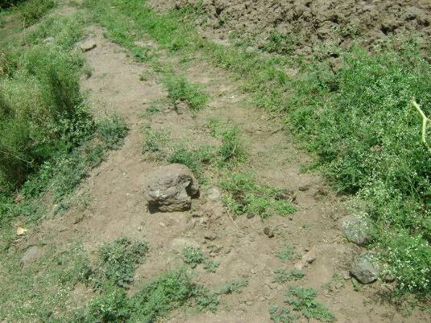 Field canals in waltane 

